undefined vs not defined in JS

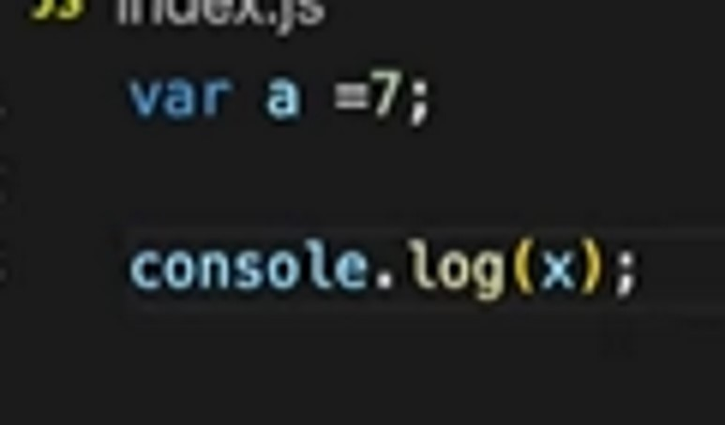

22 November 2023 19:24



Place holder until the var. Is not assign value. const x; // This will cause an error: SyntaxError: Missing initializer in const declaration





let x;

console.log(x); // Outputs: undefined

Summary

1.Undefined is a Special Placeholder which is used to reserve memory for the variables in the memory creation phase. Even before a single line of code is executed JS engine assigns undefined to the variables.

2.Not Defined means if we try to console or access any variable which is not declared in the code then we get Not Defined error.

3. JS is a loosely typed language or weakly typed language means it does not attaches its variables to specific data types like in C++ and java. 4.Remember undefined !== not defined.